Funded by the European Union’s Internal Security Fund - Police (2014-2020)

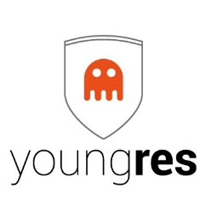

Internal Security Fund – Police - Programme (2014-2020)

823701 - YoungRes - ISFP-2017-AG-RAD

Strengthening European Youngsters Resilience through Serious Games -

YoungRes

Deliverable D5.1
DISSEMINATION PLAN

Document information
Due date of deliverable |  | 31 MAY 2019
Actual submission date |  | 27 MAY 2019
Organisation name of lead partner for this deliverable |  | MILITOS
Final Version Number |  | COMPLETE

Dissemination Level
PU | Public
RE | Restricted to a group specified by the consortium (including the Commission Services)
CO | Confidential, only for members of the consortium (including the Commission Services) |  | X

Authors list
Author | Partner
Konstantin Tsimas | MILITOS

Peer Reviewers
Reviewer | Partner

Versioning
Version | Date | Summary
DRAFT | 17-05-2019 | Kick-off meeting PPT discussion
V1 | 21-05-2019 | First version
V2 | 27-05-2019 | Second version, with Project Logo

The content of this report represents the views of the author only and is his/her sole responsibility. The European Commission does not accept any responsibility for use that may be made of the information it contains.

Table of Contents
2 Executive Summary 4
3 Introduction 5
4 Objectives 5
5 Background and Term Clarifications 6
6 Plan Principles 7
6.1 A Three-Step Process 8
6.2 A Five-Stage Procedure 9
6.3 Key Factors for Successful Communication 10
7 Project Target Groups 14
8 Project Communication Channels and Tools 14
9 Visual Identity 15
10 Dissemination Material 16
10.1 Website & Portal 16
10.2 Social media (Facebook, LinkedIn) 17
10.3 Media Presence 17
10.4 Events 18
10.5 Synergies 18
10.6 Partners’ communication potential 18
11 Project Communication Phases 18
11.1 Project Dissemination Roadmap 19
12 Project Monitoring and Evaluation 20

Executive Summary

This deliverable provides the YoungRES Project Dissemination Plan, outlining the YoungRES Project communication objectives and laying down the consortium’ Communication and Dissemination Strategy to achieve them. The plan presents the basic general principles of communication, the YoungRES Project communication phases and specific communication objectives per phase, an analysis of stakeholders, including profile and information needs, accompanied with an overview of the communication tools and channels needed to address them. The partners’ existing actual and direct communication channels are also to be assessed while all current and potential communication and dissemination tools for the YoungRES Project are dealt with in detail. This deliverable is a live document and it should be kept in mind its contents will be periodically re-adjusted, completed and/or corrected, following closely the Project’s implementation phases and intermediate results.

Introduction

This document provides the YoungRES project Dissemination Plan, outlining the project objectives and in particular its communication objectives, laying down the general principles of communication, analysing the YoungRES target groups and stakeholders, their profiles and information needs, providing an overview of the channels and tools of communication, the communication phases and the monitoring and evaluation procedures while setting a roadmap on deliverables and activities, time planning and partners’ roles.
The Dissemination Plan, laying down the common ground for project dissemination, as inextricably linked processes, is drafted at an early stage of the project implementation, acting mostly as a roadmap of the communication activities to be undertaken. Therefore, as dissemination activities are cross-cutting, running in parallel with the development of all intellectual outputs, fed by the process, the progress and the feedback received, the Dissemination Plan will be a “live” document, to be reviewed and improved on a regular basis throughout the project lifetime.

Objectives

The YoungRes project aims to overcome the acknowledged difficulty of efficient interaction with youth and vulnerable population at risk of radicalization or polarization. To do so, YoungRes advocates a new innovative approach based on digital technologies to overcome this barrier, built on previous achievements by project partners in game technology, social media analytics, and eLearning.
In particular, YoungRes aims to:
- Develop and test an educative methodology based on digital resources (specifically, serious games), in order to prevent radicalization and polarization, having selected bullying as the first of potentially several instances of such behavior;
- Create serious games (and other digital content) as a way to allow youngsters to counter bullying;
- Develop a set of controlled studies in education contexts in Spain and Finland to test the methodology;
- Create an online platform, which will be used to:
- Test the serious game-based approach for bullying identification and tracking;
- Provide a friendly interface that visualizes user’s argumentation for the game-based approach;
- Provide a qualitative and a quantitative assessment of bullying risk;
- Share resources between the different educators related to the platform;
- Train educators and other stakeholders in the methodology proposed.
In view of achieving these objectives, a number of dissemination and awareness-raising activities and tools will be used, as described in subsequent chapters of this plan.

Background and Term Clarifications

To illustrate in more depth the relationships between communication, dissemination and exploitation it is necessary to enlarge our conception of communication.
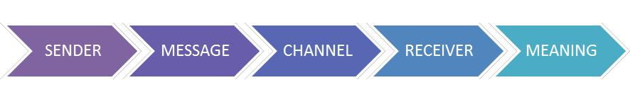
In the classic communication model, the stream from a source to a receiver is linear, hierarchical (top-down) and one-way. This model is depicted in figure 1 as follows:

Figure 1: The classic communication model
But in our networked and mediated times this model is old-fashioned and does not reflect the changes happening in the digital media era (figure 2). The complexity of the current scenario is determined by a non-linear, democratic and multi-way (“many-to-many”) model of communication in which digital social media play a key role in addition to classic, “mainstream” media, and in which professional identities and practices of journalists, bloggers, public relations professionals, advertisers and stakeholders (official bodies, companies, lobbies, NGO’s, etc.) are reformulating the public digital sphere: “Roles and channels define professional identity in the web 2.0 environment and practices associated with topics and sources are constitutive of the roles and identities of traditional journalists” (Prades et al., 2014:1).
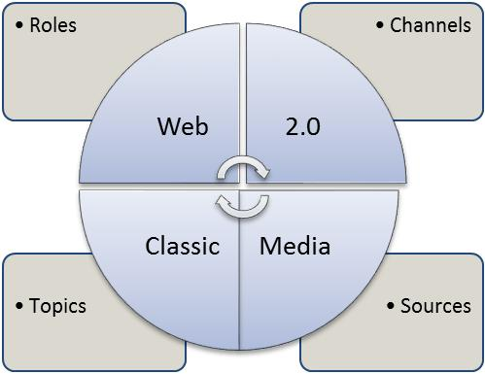

Figure 2: The new media environment
An understanding of “dissemination” and “exploitation” as communication forms allow us to adopt a holistic point of view to be taken into account when designing plans, strategies and actions in order to transfer and translate research outcomes to society.
From the more general one to the most specific in relation to the project and their social impact these key terms are defined in this way by the Horizon 2020 Annotated Model Grant Agreement:
- Communication (article 38): According to the article 38.1 (Communication activities by beneficiaries) there is an obligation “to promote the action and its results by providing targeted information to multiple audiences (including the media and the public) in a strategic and effective manner”.
- Dissemination (article 29): Article 29 establishes an obligation to disseminate results. It means “to make the results of a project public (— by any appropriate means other than protecting or exploiting them, e.g. scientific publications)”.
- Exploitation (article 28): This article determines that “each beneficiary must —up to four years after the period set out in Article 3— [which stablishes the duration and starting date of the action] take measures aiming to ensure ‘exploitation’ of its results (either directly or indirectly, in particular through transfer or licensing; see Article 30) by: (a) using them in further research activities (outside the action); (b) developing, creating or marketing a product or process; (c) creating and providing a service, or (d) using them in standardisation activities”.
In sum exploitation “means to make use of the results produced in an EU project in further activities (other than those covered by the project, e.g. in other research activities; in developing, creating and marketing a product, process or service; in standardisation activities)”.
According to the definitions, some differences can be highlighted between these terms:
Communication is about the project and results, “it reaches out to society as a whole and in particular to some specific audiences” beyond the project’s own community. It shows the benefits of research in order to “demonstrate how EU funding contributes to tackling societal challenges”. Press releases, media conferences, meetings with official bodies and with private companies, videos and podcasts, printed and/or online contents (newsletters, leaflets, factsheets, flyers, and brochures), websites and social media are some examples of communication tools.
Dissemination is about results only, it transfers knowledge “to the ones that can best make use of it” and “maximizes the impact of research, enabling the value of results to be potentially wider than the original focus”. Some examples are peer-reviewed papers, books and book chapters, presentations on scientific conferences and social events.
Exploitation recognizes stakeholders that can “make use of the results” and “concretise the value and impact of the R&I activity for societal challenges”. Datasets, indices, benchmarks, standards, software, training courses and obviously climate services fall into this category.
These differences should be considered due that the confusion between communication, dissemination and exploitation is often a barrier to achieve defined objectives in terms of spreading messages, sharing knowledge and using results.

Plan Principles

The YoungRes Dissemination Plan is based on implementing a strategic, dynamic and sustainable 360° promotion, smartly and carefully designed so as to exploit the significant and sophisticated multiplying effect of the consortium in order to inform, stimulate interest, establish engagement, strengthen project visibility, sustainability, impact and exploitation at European level, through targeted and concerted awareness raising, dissemination, media campaigning and network building, making use of all partners’ valuable, strong and extensive communication channels in this respect.

A Three-Step Process
Communication is a pre-planned but ongoing activity and continuously and gradually evolving process, far beyond the project consortium.
The first step is raising awareness about the project, its objectives, the needs addressed, planned activities, expected outcomes and the partnership, e.g. members of the consortium. It is addressed to a wider public, in an effort to build networks of interested stakeholders, willing to contribute to the design and development of the project and its results.
The second step is dissemination. According to the European Commission, “Dissemination is the planned process of providing information on the quality, relevance and effectiveness of the project results to key actors”. Dissemination refers more to the “marketing” and the promotion of particular project results and outcomes, in view of extending the project’s impact and reaching as many of the actual direct and indirect target groups of the project as possible.
The final step is exploitation and refers to the promotion of the project and its results beyond its timespan, ensuring its sustainability, including through encouraging decision-makers, organizations, institutions and other actors to incorporate project results into existing systems, practices, processes, and urging (individual) end-users to make use of the project results.
While these three steps might coincide at times, the logical sequence is (1) awareness raising, (2) dissemination, (3) exploitation:
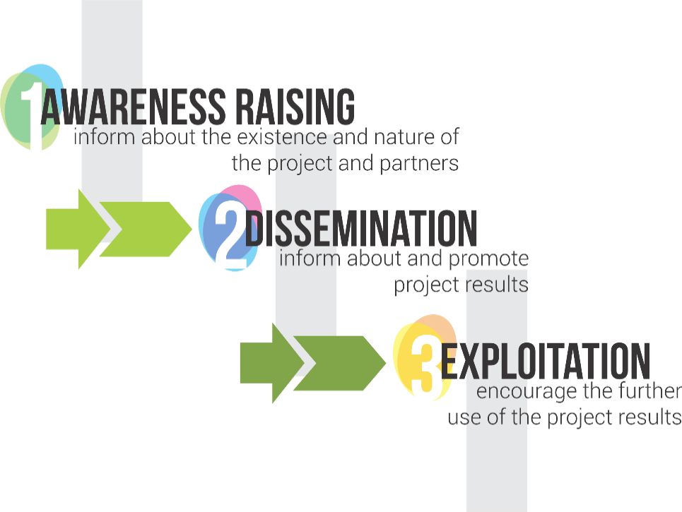
Figure 3: Three steps dissemination process
Taken together, the three steps in communication, addressing separately, jointly or in parallel different phases of the project (as will be discussed subsequently), enhance its impact, contributing significantly to its sustainability. The effective promotion of the project and its results is crucial in achieving the objectives of each project, bringing forward its added value but also incorporating the essence of EU-funded projects: to create products, tangible or intangible, that reach the targeted recipients and beneficiaries, promoting knowledge creation, contributing to a better quality of life for the citizens, enhancing social cohesion and increasing European competitiveness.

A Five-Stage Procedure

Within each of the aforementioned three-steps process of the Communication Strategy, a five-stage procedure is implemented for the development and effectiveness of communication messages, implementation and promotion of communication activities, as follows: (1) plan, (2) implement, (3) monitor, (4) adjust and (5) evaluate.
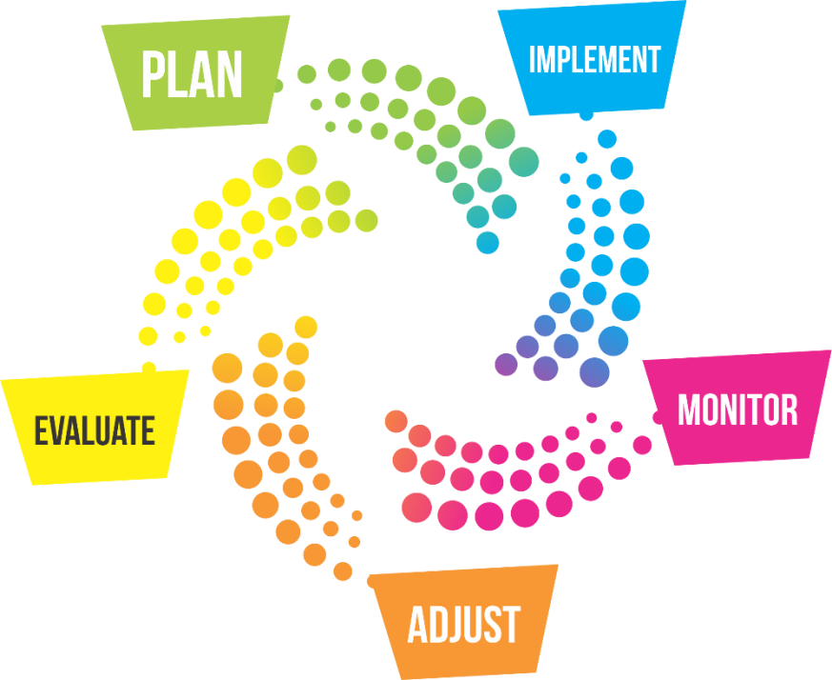
Figure 4: Five stage for the development and effectiveness of communication messages
In particular:
- Plan: The planning stage involves designing the essential elements of the Communication Strategy, defining the phases along with the messages to be promoted and the activities to be implemented, integrating them into a sustainable working document, the “Dissemination Plan”. This document constitutes the roadmap to be followed throughout the lifecycle of the project, laying down the common ground and understanding on communication issues as well as the processes for its implementation along with evaluation indicators.
- Implement: The implementation stage is about carrying out and coordinating all activities provided for in the Dissemination Plan, while looking for synergies and partnerships for a multiplier effect. The implementation stage is the most demanding in terms of resources and it needs to go hand-in-hand with the next stage: the monitoring stage.
- Monitor: The monitoring stage is crucial in order to achieve the project communication objectives. It is important to regularly measure the impact of every activity and message used by all participating partners in the project in this direction. Number of recipients of communication messages, number of people impacted by dissemination tools, social media statistics (likes, follows), number of answers in polls etc. are considered valuable indicators of the effectiveness of the communication and dissemination activities. This monitoring will ensure a better understanding and guarantee vigilance for better guiding the communication outputs, which brings us to the adjustment stage.
- Adjust: The adjustment stage ensures that all “messages sent”, e.g. indications given, by the wider community, including direct and indirect target groups, have been received and that the Dissemination Plan takes them into account in introducing corrective actions, adjustments, additions or any other action needed in order to ensure that actual performance and impact of the implementation stage matches the one foreseen during the planning stage.
- Evaluate: Following the end of the project, and therefore the communication and dissemination activities, a comprehensive evaluation takes place. This evaluation, based also on the feedback from the regular monitoring stages throughout the project, aims to identify the points and key issues that can or need to be improved and/or enhanced in view of achieving the maximum impact and have an amplified outreach, increasing the number of people that have been informed about and/or engaged with the project. This stage is key for the sustainability and exploitation of the project results following the end of the project implementation.

Key Factors for Successful Communication

A successful communication with wide outreach and impact is highly dependent upon a number of additional crucial key factors and criteria, providing the basis for any communication strategy. The messages to be communicated and disseminated throughout the project implementation need to be carefully crafted, along the lines of basic concepts of communication that ensure the maximum reach and impact. The messages are a valuable tool to achieve the project objectives. Each communication message is a value proposition.
Some of the basic communication concepts relating to communication messages and channels could be articulated as follows:
Know your audience: Break-down different stakeholders’ and target groups’ communication needs, interests and feedback and base communication strategies and messages on the specific audience analysis’ results and outcomes.
Target well: Apart from different information needs, each audience has also different levels of access to information channels and tools. Select the communication channel for each target group separately to be most effective. Explore choices of channels and build on them, taking into account factors like language, age, education level, etc. Take advantage of already existing communication vehicles, fora and opportunities. Make use of existing, including third-party, networks, events and media. Avoid unnecessary waste, seek and exploit multiplier effects. Go for the best value for money solution. Make sure target group does not incur any costs (other than time needed to read an email/message and engage!).
Engagement is crucial: Communication is an ongoing activity, going on even after the end of the project. Communication is also a two-way process. Include and engage stakeholders in developing information as the project evolves. Listen to feedback: it can be as important as delivering the message. Keep audience in the loop by regularly targeting, informing and updating them in a personalised way, as possible. Take into account / cater for the special needs of target groups, e.g. people with disabilities. Make the project visible, useful and indispensable. When the audience gets useful and interesting information from a project, they are eager to spend more time on it while sharing it with their peers.
Crafted messages: It is important that every message reaches and remains with as many recipients in each target group(s) as possible. To ensure maximum impact, all broad-based communications must be consistent and coherent in themes and messages, including in terms of structure, language, image, genre, amount, etc., as well as appropriate for each target group / project phase. Communication messages must also be clear and simple, in order to attain their accurate understanding by the target group(s); useful, true, realistic and important while also engaging, motivating & intriguing, in order to gain the reaction, contribution, loyalty and trust of your target group(s). Messages should also be flexible to be multiplied through various communication media to obtain the maximum potential outreach and a multiplier effect. They should be demonstrating benefits, e.g. benefits of participation to the project for the target group(s), for society, for economy, etc. Messages should be placed in appropriate communication places/environments while controlled use of repetition helps messages be remembered. Messages should be distinguished from general flow of information and not be overloaded with detail, i.e. they should stand out! Provide regular project information about the progress, findings and outcomes. Involve stakeholders in the process. Create an environment where project partners and stakeholders can constructively work together to define messages in view of achieving the project’s main objectives.
Timing is of essence: Timing is everything. It can make your message fly or take it to the ground. Make sure that communication is shared in a timely manner. Make use of existing opportunities / milestone events / activities / celebrations / news / actuality / policy-making to link your message and project to and maximise your visibility and impact. Link your messages appropriately and as necessary to the project communication phases identified.
Handle flow: Coordinate communication messages with project phases. Choose your battles and do not try to communicate all elements in one go. Messages should be designed and adapted for each phase of the project. Keep communication of the project and all related output ongoing.
Increase impact: Start from the powers lying within the project. Exploit the consortium partners’ communication channels. Build and sustain enthusiasm for the project. Promote best practices. Promote the participating and engaging stakeholders and offer them visibility. Ensure continuity of your communication. Keep audience engaged. Build communication liaisons and synergies within the consortium, with key stakeholders, with other projects, with the wider community. Monitor and assess progress. “Reboot” if and when necessary.
Gain trust: Ensure the high quality of your messages as well as of the outcomes of the project you are advocating for. Have something important to show for. Respect the legal framework and apply good practice when handling personal data.
Based on the above, the following checklist is a useful tool that helps assess in a quick and reliable way whether the communication message chosen will actually do the work, e.g. deliver the planned results and achieve the communication objectives and impact.

A message is a ‘value proposition’
Key questions to ask:
- WHAT is to be communicated?
- WHO are the recipients?
- HOW to do it, e.g. messages and tools to draw attention and spark interest?
- WHEN to do it, e.g. when best to schedule/launch/implement the activities?
- What are the available resources, human and financial?
- How to assess impact and effectiveness?
- How to gain trust and respect?
Messages | Tools
Are they:  - Consistent?  - Appropriate for each target group / each project phase?  - Clear & Simple?  - Useful, True, Realistic & Important?  - Engaging, Motivating & Intriguing?  - Flexible to be multiplied through various communication media channels?  - Demonstrating benefits?  - Placed and repeated appropriately?  - Standing out? | Are they:  - Appropriate for each target group / each project phase?  - Time-effective?  - Cost-effective?  - Capitalizing on existing consortium partners' channels?

Finally, besides knowing your audience and communicating the right message at the right time through the right channels and the right ways, there are some additional important factors for increased impact, mostly related to the project itself, its processes and its results.
Output quality: As a general rule, valid for every project, there is a direct causal relation between the quality of the project results and the prospects for successful and effective exploitation. The higher the quality of the project results, the higher the prospects of sustainability and successful exploitation of the outputs produced within the frame of the project. Quality evaluation and management procedures by the project leader in this respect are vital. Furthermore, the project team is set to include a highly respected Advisory Committee, which will consist of eminent members from academia, professional practitioners and internationally recognized experts in the field. This ultimately will contribute to and improve quality management of the project’s activities.
Output ongoing relevance: It is essential that the project results, products and approaches are useful, addressing a real problem or challenge in an effective, timely and relevant manner. It is also important that the outputs are up to date and appealing to the future end-users, presenting a solution or a way to improve the status quo.
Output ongoing availability: It is essential that the project results and tools/products are available at no cost, continuously accessible and user-friendly.
Output transferability and adaptability: Another important precondition is that the results and outputs of the project should be highly adaptable to the specific circumstances of different countries, institutions and sectors involved. The consortium will need to ensure that the results are equipped with the necessary methodological and content flexibility to address this challenge, thus increasing their added value.
Early identification and engagement of stakeholders: It is vital that relevant direct and indirect target groups of stakeholders and potential end-users of the YoungRES project results are clearly identified and defined during the early stages of the project implementation.
Clear definition of advantages for end-users: A high degree of usability is dependent upon the capacity of the project and the partnership to clearly communicate the advantages of using the instruments and outputs for the final target group and end users. The project portal/website, the social media accounts and the online database certainly provide a great platform for increasing visibility and outreach of the project and its results to potential end-users.
Involvement of consortium members: sense of ownership and motivation: A key element for successfully sustaining the project results is the maintained and continuous commitment of all consortium partners.
Extended network of partnerships and development of synergies: A well-established network of contacts, partners and relationships, across sectors, including public and private institutions and actors as well as across countries, securing an extended geographical scope, are the best guarantees for sustainability and a multiplier effect of the project results. Starting from its own sources, namely the consortium members and their resources and networks, the project needs to build on this foundation and expand outreach. It must be noted that as part of the YoungRES planned activities, a dedicated Final Conference will be organized with active participation of legal education specialists, radicalisation prevention authorities and policy makers from various European countries. This presents a unique opportunity to promote the YoungRES methodology, preliminary findings and goals well beyond the face to face boundaries of the project partners.
*TBD - Capitalisation on project results: A maximum outreach is achieved when the partnership capitalises on the project results through pursuing a commercialisation process and/or through a transfer of knowledge and innovation through other projects, building on the project results and presenting them in different groups of stakeholders, engaging different countries and institutions at international level.
Regarding commercialisation, securing continued financing beyond the project lifetime is strongly linked to institutional support and can be better achieved by mixing different sources of financing: public, private, national, regional and international. In this respect, own consortium partners’ funds for sustaining part of the project activities are highly desirable, including for higher rates of success in securing third-party financing.

Most of these factors are already, at this early stage of the project, satisfied by the YoungRes project and the consortium partners, as will be discussed below, increasing the prospects for a successful dissemination and wide impact.

Project Target Groups

The YoungRes project targets the educators' community (teachers in schools) as well as the professionals (social workers; psychologists in youngster support centers; police officers; policy and decision-makers at local, regional, national and EU level). These stakeholders are specialised engaged in the key themes of the project, owning expert skills and knowledge and undertaking related, targeted activities. As such their information needs are for targeted online and offline in-depth and specialised communication; detailed information and instructions of implementation in the case of the teachers, who will be assisting the Project's implemntation (testing) phase as facilitators.
The project also targets the general public, i.e. stakeholders that are directly affected by the project outcomes but are indirectly involved in their development (ie. parents, civil society). The information needs of such stakeholders are for basic, short, direct, easy and friendly communication messages; targeted online and offline communication on benefits they will experience and receive from the research and the solutions identified.

Project Communication Channels and Tools

There is a variety of communication and dissemination tools and actions at the consortium’s disposal. This section presents and describes the potential as well as the limitations and proposes how to best make use of the available tools, activities and communication channels of the YoungRes Project.
The YoungRes project overall communication channels and tools can be grouped in three main types: (a) in-person / face-to-face, (b) written / paper-based, and (c) technology-based.

IN-PERSON / FACE-TO-FACE | WRITTEN / PAPER-BASED | TECHNOLOGY-BASED
Participation in meetings of European, national, and local networks | Publications in high profile international scientific journals | Project Website and Portal
Scientific Conference participation | Reprints selective distribution | Social media (e.g. Twitter, Facebook, Linkedin)
Workshops with teachers (facilitators) | Posters / Banners as needed by partners’ own activity | Project e-Presentation (powerpoint version of brochure)
Partners’ own channel SYNERGIES | Project brochure | Online serious games “teasers”
Common Project image & layout // Logo & Motto // Reference to EU funding

Notably, as also partly shown at the table above, no matter which tools and actions are being used and by whom, there are two underlying principles:
a) the YoungRes project must always be represented in a common project image and layout, using always the common project logo, where applicable, including reference to the European Commission funding and
b) there is no one single activity and/or tool that can achieve all targets. A mix of communication channels is always advised and deemed necessary.

Visual Identity

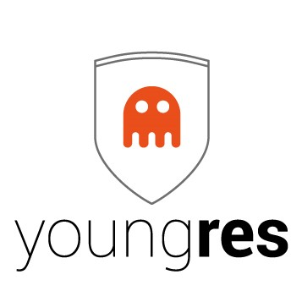
It is highly significant for the project identity and dissemination purposes that the project logo is representative and closely linked to the aims and nature of the project, including also a targeted, comprehensive and representative motto. In the case of the YoungRes project, the logo is quite communicative of the message of the project directly, at a glance. This element makes a successful project image, which needs to be utilized in all communication, intra- and extra-consortium, and dissemination of the project and its results to establish and ensure a common “look and feel”.
Endorsing a unique image towards all communication concerning the YoungRes project contributes to raising awareness about the project. Visibility is crucial for the promotion of the project. It helps to clearly identify the project and to build a common identity. For these reasons, it is important that all documents distributed or any dissemination activity undertaken by any of the YoungRes consortium partners contain:
- project logo
- EU flag
- EU funding acknowledgement: “Funded by the European Union’s Internal Security Fund - Police (2014-2020) ”
and when it comes to publication of substantial content, such as reports, publications, studies, etc. also the following
- the European Commission disclaimer: “The content of this [report/study/ article/publication…] does not reflect the official opinion of the European Union. Responsibility for the information and views expressed in the [...] / [therein] lies entirely with the author(s). Reproduction is authorised provided the source is acknowledged. European Union, [year]”
The EU rules and respective logos are available at this link http://ec.europa.eu/ipg/basics/legal/notice_copyright/notices_disclaimers/index_en.htm

Important: The consortium partners’ logos, albeit not imperative, should also be included in the communication for identification purposes. It is important for the end-users and target groups as well as for the wider public to see who is behind the project not only because it makes a project more accessible and personalized but also because it increases its authority and credibility, especially when partners and their expertise are widely known and recognized.

Dissemination Material

The project basic promotional material consists of:
- Logo
- Project website
- Social Media: Facebook page, Twitter account, Linkedin
- Project Brochure in English
- Project PPT presentation (brochure-based)
- Electronic file (EPS) for printing a Poster in English
- Electronic file (EPS) for printing a Banner in English
The common project dissemination material has a dual function: on the one hand, the uniform communication of the project information and objectives and, on the other hand, the uniform - with consistent colour scheme and fonts - presentation to the target groups and the general public and in line with the project image and visual identity.
The material serves to present and raise interest in the project goals and objectives, engaging potential users to be involved in the project, to visit the project website, social media profiles and online database and to contribute their input, feedback and expertise, while making use of the project results.
The brochure and banners, in particular, will be available in both electronic versions, published also on the project website and social media, as well as in printable versions for focused local use and distribution.

Website & Portal

The project website is the main communication tool of project, will be available at http://www.youngres-project.eu. It will provide details about the YoungRes project, addressing the following questions:
- What is the project about, at a glance?
- Why is the project needed?
- What are the project deliverables and research undertaken?
- Who is implementing the project?
- What news is there in the project area of interest and focus?
- What news is there on project implementation?
- What are the means of interaction with the project (project email, social media, stakeholder database)?
- What are the project synergies?
Moreover, it will be able to provide for
- An interest registration mechanism to gather, inform and potentially engage possible interested stakeholders and
- a facilitators' portal area in the form of information and knowledge gathering and sharing community, where interested stakeholders can exchange readings and material, post queries and comments and interact with project partners.
The website and portal will be regularly maintained and updated in a timely manner with project specific news on its progress, deliverables and milestones, but also with general information on EU policy developments, initiatives, articles, publications, conferences and other events on innovation in urban wastewater management.

Social media (Facebook, LinkedIn)

Social media differs from traditional media in many ways, including quality, reach, frequency, usability, immediacy and permanence. The most relevant to the YoungRes project social media, with the highest levels of impact, will be selected for use and dissemination of the project results:
- Facebook, increasingly popular with youngsters but also teachers, academics and society as a whole and
- LinkedIn, a business- and employment-oriented social networking service, popular with professionals as well as academics and policy makers.
- More social media will be tested (such as Twitter) and continued presence there will be evaluated according to response metrics. As was previously stated, the Dissemination Plan is a live document, not a definitive, rigid plan, so any emerging social media possibilities will be evaluated and possibly included in the Dissemination actions.
As social networks exposure has gained huge momentum worldwide, the project social media will be widely used for dissemination and exploitation purposes.

Media Presence

To satisfy the more traditional forms of media, YoungRes press releases will be issued on an as-needed basis to highlight important milestones, phases and events during the project lifetime. These press releases, suitable for downloading and printing also via the project website, will be communicated to each partner’s own communication channels and media network at local, regional, national and European level.
Other media presence, e.g. through articles, interviews, newsletters, publications, will also be sought by project partners and all related opportunities will be exploited in view of increasing project visibility and dissemination and engaging more stakeholders.

Events

For dissemination purposes, the presence and presentation of the YoungRes project to events organised from within the consortium partners or by third parties (e.g. EU bodies, professional organisations), like workshops, conferences, info-days, seminars, is a very effective way to reach and engage all target groups as well as to increase visibility and outreach of the project, promote and serve its objectives and spread the benefits of its results through knowledge transfer. It is therefore highly important for YoungRes to aim to be physically present at events throughout EU28 and beyond (e.g. set-up of info booth, leaflet distribution, presentations & speeches, etc.) in order to maximize publicity, get into direct contact with the most important target groups, increase, create synergies and establish partnerships.

Synergies

Establishing close links to relevant initiatives, projects, institutions and other key stakeholders in the thematic areas of the YoungRes project is an excellent way to increase visibility for the project and reach new untapped target groups and stakeholders. Exchanging logos, invitations to events and thus linking YoungRes to international, European, national or regional campaigns and initiatives will therefore also be a target of the dissemination efforts.

Partners’ communication potential

In conjunction with the channels and tools described above, taken separately or jointly, it is important to note the increased dissemination potential of the YoungRes project consortium. Notably, the project partners, European University centres and institutions as well as private companies, associations and organisations engaged in research, development and innovation of urban wastewater management systems, have direct access to the majority of stakeholders within the project target groups and multiple ways to reach them (e.g. mailing lists, newsletters, events and conferences, social profiles, meetings, networks, stakeholder databases etc.). In addition, the project partners will create, update and expand a stakeholders database for targeted dissemination and networking throughout the project.

Project Communication Phases

The communication and dissemination of a project is an ongoing and systematic process through all the tools and media developed and utilized in this respect. However, particular phases/milestones can be identified. These phases are closely linked and dictated by the project implementation process and the intellectual outputs produced.
The YoungRes project presents 6 basic milestones for increased dissemination, alongside the regular and continuous dissemination activities during the project implementation, as follows:
- Beginning of project (logo & website); selection of the (external) Advisory Board experts
- Development of the Methodology
- “Beta-testing” of pilot Serious Game
- Full Testing of the Serious Game;
- Facilitators’ data gathering & feedback analysis; drawing of conclusions
- Final conference – Presentation of final results and future recommendations
Each of these milestones, linked to outputs or planned activities, will need to be accompanied by the related messages to highlight the respective stage of the project and a mix of all dissemination tools will be used.

Project Dissemination Roadmap

Activity | Partner(s) | Deadline | Current Status
Dissemination Plan D5.1 (initial version, to be constantly updated) | Militos | M1 | DONE
Visual Identity (logo) | Militos | M1 | DONE
Project Website | Militos | M3 | Underway
Social Media Accounts | Militos | M3 | --
Project brochure (and PPT) | Militos | M6 | --
Press releases for major deliverables | Militos & all |  | --
Scientific Papers (for Journals and Conferences) | UAM, OULU |  | --
Final dissemination and outreach initiatives report | Militos & all | M24 | --

Project Monitoring and Evaluation

As described above, during ongoing implementation of communication activities, their monitoring, adjustment, evaluation and impact assessment are essential. This process requires YoungRes partners to gather data, internal (i.e. internal processes, communication, etc.) as well as external (i.e. participants, invitations, registrations, feedback, etc.), as only a comprehensive compilation can ensure a complete and accurate evaluation.
This data is to be analysed and assessed against the quantitative and qualitative indicators, most provided in the proposal and mentioned here below, in order to determine the level of fulfilment of the project communication objectives.
The quantitative and qualitative indicators are as follows:
- # of visitors to project website
- # of downloads of research papers
- # of members and people reached through project social networks
- # of project target group stakeholders contacted/engaged
- # of participants to the project events and final conference
- # of press releases, publications, newsletters etc. & # of recipients
- # of presentations/participation at third-party conferences and events
- # of synergies developed
- type and coverage of conferences and events
- type and coverage of press clippings
- profile of stakeholders reached and engaged through the different activities
The monitoring tools for evaluation of YoungRes project dissemination are:
- Dissemination archive for reporting (first time for the Mid-Term report, then for the Final Report)
- Information exchange among consortium partners during the monthly virtual meetings
- Synergies and feedback from synergies' partners
- Registrations for information through website and social media
It seems quite probable that specific metrics will be introduced once the project's testing phase is underway, in order to be able to obtain concrete figures measuring its success.

Concluding Remarks

The Dissemination Plan addressing dissemination activities is crucial in order to set the basic principles and planning, present and capitalise on the communication tools available, establish a monitoring procedure and coordinate partner activities, all in view of achieving wider outreach and extensive project visibility. As stated, the Dissemination Plan is a “living document” and as such it is not only possible but also imperative that it is adapted, enriched, fine-tuned and redefined throughout the process with the participation of all partners. After all, dissemination is a team effort.

